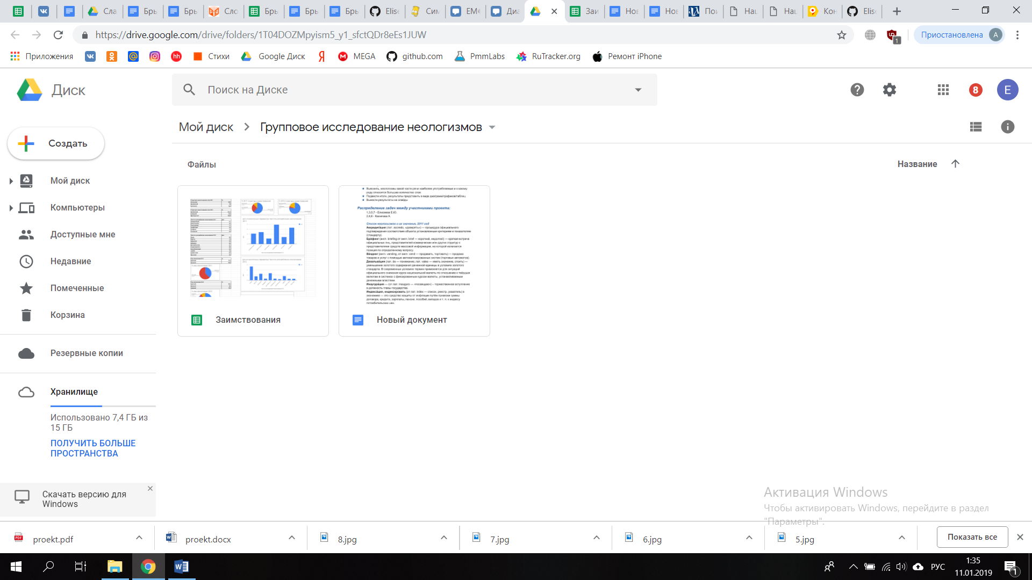

<https://drive.google.com/drive/folders/1T04DOZMpyism5_y1_sfctQDr8eEs1JUW>